**SYNOPSIS**

This project is based on Online Retailing which basically uses the concept of electronic commerce in which a user is able to buy products available on the website. This program is meant to create a simple user interface with simple instructions and alerts.

The user first enters their choice of products. They are then given the choice of viewing the features of the products they wish to buy. After the user is satisfied with their choice, they can either proceed with the bill or continue to shop for more products. Payment methods are selected by the user and the final bill is displayed.

**TABLE OF CONTENTS**

|  |  |  |
| --- | --- | --- |
| **SERIAL NO.** | **TOPIC** | **PAGE NUMBER** |
| 1. | Introduction | 1 |
| 2. | Implementation | 2-13 |
| 3. | Result And Analysis | 14-16 |
| 4. | Conclusion and Future Enhancements | 17-18 |
| 5. | References | 19 |

**INTRODUCTION**

Online Retailing INTRODUCTION Online Retailing is gaining ground very fast as an accepted and used business paradigm. eCommerce has a wide scope, it deals with not only activities which are related to transfer of goods & services but also with the enhancement and marketing of trade business. The number of business houses implementing web sites by providing functionality for performing commercial transactions over the web is increasing by the day.

It is reasonable to say that the process of shopping on the web is becoming very commonplace and is now an integral part of many businesses and is used primarily to boost sales revenue, to attract new customers and to survive in today’s competitive business environment. Online Retailing is very advantageous as it provides flexibility in many aspects of retail and business. It provides a wide range of options for products which might not be available in traditional offline stores.

Selling products and services online is less costly than traditional methods because there are various high overhead costs that are included in offline commerce which include recurring expenses such as store management cost, counter cost, etc. It also has the added benefit of lesser time consumption. Most of the eCommerce transactions are digital such as by using credit, debit card, and net banking. Sellers or online retailers receive payments through payment gateway because of this method buyers and sellers are always under Government scrutiny, hence providing a Transparent Business System.

The objective of this project is to develop a general-purpose e-commerce store where products like novels, makeup products, mobile phones can be bought from the comfort of home. The development of this console-based application was carried out on the Eclipse IDE using the Java programming language. It is an interface for customers to browse a catalogue and order various products online. The selected items are collected in a shopping cart.

At checkout time, the items in the shopping cart will be presented as an order. At that time, more information will be needed to complete the transaction. The customer will be asked to fill basic information, shipping address, and payment information such as credit card number, thereby confirming the order.

**IMPLEMENTATION**

*Introduction:*

Implementation strategy is the process of defining how to bring the strategic plan to life. To execute the objectives outlined in the strategic plan, we must define how we have implemented each aspect. Therefore, without an implementation strategy, it can be difficult to identify how we have achieved each of our stated goals and objectives. On the same lines, this is our implementation strategy behind this program.

In this section we will be attaching a copy of the code that we have used to design the structure of our project. It comprises of several topics that we have covered this semester under Object Oriented Programming with Java. To name a few, we have made use of the following:

* Arrays
* Switch Cases
* Exception Handling
* String Functions
* Access Specifiers

In this program, the user is able to select the product that He/She wishes to purchase. The details of the product are then displayed and asks the user for a confirmation. It also asks if the user wishes to add any more items from the list of items available. It comprises of several options such as viewing of the items in the cart, deleting an item from the cart or add another item. It also asks for your payment options. It displays a bill of all the items that the user has added to the cart. After the user has input all the personal details, the code generates the estimated delivery date and invokes the whole shopping cycle all over again.

Such a program can be used in fields like E-commerce, E-shops, etc. Such an implementation of such a program in these fields not only eliminates the requirement for manual labor, but also performs automated operations with optimum efficiency which is an uncertainty when it comes to humans. The essence of this program lies in its increased complexity.

This program has been designed with exceptional precision to handle every action that the user desires the system to perform. With no loop holes, this program ensures absolute efficiency so that you can totally rely on it and shop carelessly!

*Source Code:*

**import** java.io.*;

**import** java.util.*;

**class** ecom

{

**public** **double** total = 0.0, amt=0.0, change=0.0;

**public** **int** serial[] = **new** **int**[46];

**public** String items [] = **new** String[46];

**public** String sel[] = **new** String[46];

**public** **double** cost[] = **new** **double** [46];

**public** **double** price[] = **new** **double** [46];

**public** **double** quantity[] = **new** **double** [46];

**public** **int** c=0,z=0,p=0,j=0,y,w,i,d, del=0, a;

**public** String g= " ";

**public** **void** item()

{

items[1] = "Angels & Demons";

items[2] = "Desert God";

items[3] = "Steve Jobs";

items[4] = "The Deathly Hallows";

items[5] = "The Immortals Of Meluha (Shiva Trilogy)";

items[6] = "Color Sensational Creamy Matte Lipstick";

items[7] = "Enrich Lip Crayon";

items[8] = "Get Inked! Sketch Eyeliner";

items[9] = "Eyeconic Kajal";

items[10] = "BB Cream";

items[11] = "OnePlus 7t";

items[12] = "Samsung Galaxy S10";

items[13] = "iPhone 11 Pro";

items[14] = "Pixel 3";

items[15] = "Redmi Note 7 Pro";

cost[1] = 163;

cost[2] = 392;

cost[3] = 550;

cost[4] = 700;

cost[5] = 399;

cost[6] = 299;

cost[7] = 225;

cost[8] = 450;

cost[9] = 275;

cost[10] = 124;

cost[11] = 39999;

cost[12] = 76900;

cost[13] = 99900;

cost[14] = 47990;

cost[15] = 14400;

}

**public** **void** info()**throws** IOException

{

**int** feat;

Scanner s=**new** Scanner(System.***in***);

System.***out***.println(" THE FOLLOWING PRODUCTS ARE AVAILABLE ON OUR WEBSITE: \n\n ");

System.***out***.println(" NOVELS\n");

System.***out***.println(" 1. Angels & Demons ");

System.***out***.println(" 2. Desert God");

System.***out***.println(" 3. Steve Jobs");

System.***out***.println(" 4. The Deathly Hallows");

System.***out***.println(" 5. The Immortals Of Meluha (Shiva Trilogy)\n\n");

System.***out***.println(" MAKEUP\n");

System.***out***.println(" 6. Color Sensational Creamy Matte Lipstick");

System.***out***.println(" 7. Enrich Lip Crayon");

System.***out***.println(" 8. Get Inked! Sketch Eyeliner");

System.***out***.println(" 9. Eyeconic Kajal");

System.***out***.println(" 10. BB Cream\n\n");

System.***out***.println(" MOBILE PHONES\n");

System.***out***.println(" 11. OnePlus 7t");

System.***out***.println(" 12. Samsung Galaxy S10");

System.***out***.println(" 13. iPhone 11 Pro");

System.***out***.println(" 14. Pixel 3");

System.***out***.println(" 15. Redmi Note 7 Pro\n\n");

System.***out***.println("Enter a serial number from 1 to 15 to see the features of the product that you are interested to buy:");

feat = s.nextInt();

**switch**(feat)

{

**case** 1 : System.***out***.println("\nAngels & Demons");

System.***out***.println("Author: Dan Brown");

System.***out***.println("Angels & Demons is a 2000 bestselling mystery-thriller novel \nand published by Pocket Books and then by Corgi Books.");

System.***out***.println("The novel introduces the character Robert Langdon, who recurs as \nthe protagonist of Brown's subsequent novels. ");

System.***out***.println("Cost - Rs 163\n");

check();

**break**;

**case** 2 : System.***out***.println("\nDesert God");

System.***out***.println("Author: Wilbur Smith");

System.***out***.println("It was first published in 2014.");

System.***out***.println("It is part of a series of novels by Smith set to Ancient Egypt \n and follows the fate of the Egyptian Kingdom through the eyes of Taita, \n a multi-talented and highly skilled eunuch slave.");

System.***out***.println("Cost - Rs 392\n");

check();

**break**;

**case** 3 : System.***out***.println("\nSteve Jobs");

System.***out***.println("Author: Walter Isaacson");

System.***out***.println("Steve Jobs is the authorized self-titled biography book of Steve Jobs. \n The book was written at the request of Jobs by Walter Isaacson, a former executive at CNN and TIME \n who has written best-selling biographies of Benjamin Franklin and Albert Einstein.");

System.***out***.println("Cost - Rs 550\n");

check();

**break**;

**case** 4 : System.***out***.println("\nThe Deathly Hallows");

System.***out***.println("Author: J K Rowling");

System.***out***.println("Harry Potter and the Deathly Hallows is a fantasy novel and the seventh and final novel of the Harry Potter series. \n It was released on 21 July 2007 in the United Kingdom by Bloomsbury Publishing, \n in the United States by Scholastic, and in Canada by Raincoast Books. ");

System.***out***.println("The novel chronicles the events directly following Harry Potter and the Half-Blood Prince (2005) \n and the final confrontation between the wizards Harry Potter and Lord Voldemort. ");

System.***out***.println("Cost - Rs 700\n");

check();

**break**;

**case** 5 : System.***out***.println("\nThe Immortals Of Meluha (Shiva Trilogy)");

System.***out***.println("Author: Amish");

System.***out***.println("The Immortals of Meluha is the first novel of the Shiva trilogy series. ");

System.***out***.println("The story is set in the land of Meluha and starts with the arrival of the Shiva. \n The Meluhans believe that Shiva is their fabled saviour Neelkanth. Shiva decides to help the Meluhans \nin their war against the Chandravanshis, who had joined forces with a cursed Nagas; \n however, during his journey and the fight that ensues, Shiva learns how his choices actually reflect \n who he aspires to be and how they lead to dire consequences.");

System.***out***.println("cost - Rs 399\n");

check();

**break**;

**case** 6 : System.***out***.println("\nMaybelline Color Sensational Creamy Matte Lipstick");

System.***out***.println("Color: Craving Coral");

System.***out***.println("Finish: Matte");

System.***out***.println("Irresitible color meets precious honey nectar for a supremely sensational lipstick.");

System.***out***.println("Cost - Rs 299\n");

check();

**break**;

**case** 7: System.***out***.println("\nLakme Enrich Lip Crayon");

System.***out***.println(" It is a newly formulated lip color crayon, for a soft texture and smooth matte finish. Get soft and colorful lips every day, in 10 different shades of your choice. \n The Lakme Enrich Lip Crayons contain a high level of mineral powders, giving your lips a soft matte finish. ");

System.***out***.println("Cost - Rs 225\n");

check();

**break**;

**case** 8 : System.***out***.println("\nNykaa Get Inked! Sketch Eyeliner");

System.***out***.println("Color: Onyx 01");

System.***out***.println("Featuring a slender and precise felt tip, this intensely pigmented, waterproof pen lets you \nachieve intense black liquid lines effortlessly. Every stroke gives you an unparalleled, defined fluid finish. \nFine and natural or broad and bold - any look is easy-peasy with this artist!");

System.***out***.println("Cost - Rs 450\n");

check();

**break**;

**case** 9 : System.***out***.println("\nLakme Eyeconic Kajal");

System.***out***.println("Deep black Kajal that beats time! Perfect for everyday use, the Lakme Eyeconic Kajal is available in 4 gorgeous shades.");

System.***out***.println("Lasts 24 hours");

System.***out***.println("Water-proof and Smudge-proof");

System.***out***.println("Twist the tip to open and apply!");

System.***out***.println("Cost - Rs 275\n");

check();

**break**;

**case** 10 : System.***out***.println("\nGarnier Skin Naturals BB Cream");

System.***out***.println("SPF 24 | PA+++");

System.***out***.println("For natural skincare lovers, Garnier has developed a 5-in-1 natural BB cream with green tea extract and Vitamin E. \nMade from 90% naturally derived ingredients and mineral pigments, this all-in-one BB cream \ncontains a 24-hour moisturizing formula which evens skin tone, \nprovides a radiant complexion, reduces the appearance of skin imperfections and protects skin \nagainst environmental pollutants. Did we mention that this natural bb cream is completely free \nof parabens, silicone, artificial colorants and is vegan? So, what are you\nwaiting for? Buy this bb cream now! Available in light, medium \nand extra light shades to best match your complexion.");

System.***out***.println("Cost - Rs 124\n");

check();

**break**;

**case** 11 : System.***out***.println("\nOnePlus 7t");

System.***out***.println("Color: Glacier Blue");

System.***out***.println("8GB RAM | 256GB Storage");

System.***out***.println("Oxygen OS | Android 10");

System.***out***.println("Fluid AMOLED Display");

System.***out***.println("Cost - Rs 39,999\n");

check();

**break**;

**case** 12 : System.***out***.println("\nSamsung Galaxy S10");

System.***out***.println("Color: White");

System.***out***.println("8GB RAM | 512GB Storage");

System.***out***.println("Android OS");

System.***out***.println("Cost - Rs 76,900\n");

check();

**break**;

**case** 13 : System.***out***.println("\nApple Iphone 11 Pro");

System.***out***.println("Color: Space Grey");

System.***out***.println("Apple iOS");

System.***out***.println("64GB Storage | Triple Camera System");

System.***out***.println("Cost - Rs 99,900\n");

check();

**break**;

**case** 14 : System.***out***.println("\nGoogle Pixel 3");

System.***out***.println("Color: Clearly White");

System.***out***.println("4 GB RAM | 64GB internal memory, expendable upto 64GB ");

System.***out***.println("Android 10 OS");

System.***out***.println("12.2MP Rear Camera | 8MP+8MP Dual Front Camera");

System.***out***.println("5.5 inch");

System.***out***.println("Cost: Rs. 47,990\n");

check();

**break**;

**case** 15 : System.***out***.println("\nMi Note 7 Pro");

System.***out***.println("Color: Neptune Blue");

System.***out***.println("6 GB RAM | 64GB Storage");

System.***out***.println("Android OS");

System.***out***.println("48MP+5MP AI Dual Camera");

System.***out***.println("Cost: Rs.14,400\n");

check();

**break**;

**default**: System.***out***.println("Please enter a valid serial number\n");

check();

}

}

**public** **void** check()**throws** IOException

{

Scanner s=**new** Scanner(System.***in***);

**int** o;

System.***out***.println(" Press \n 1. To continue to see the features of the products that you wish to buy. \n 2. To start buying. ");

o = s.nextInt();

**switch**(o)

{

**case** 1: info();

**break**;

**case** 2: input();

**break**;

**default**: System.***out***.println("Invalid number, please try again");

check();

}

}

//display the items available in the website

**public** **void** display()

{

System.***out***.println("\n\n$$$$$$$$$$$$$$$$$$$$$$$$$$$$$$$$$$$$$$$$$$$$$$$$$$$$$$$$$ WELCOME TO OUR WEBSITE! $$$$$$$$$$$$$$$$$$$$$$$$$$$$$$$$$$$$$$$$$$$$$$$$$$$$$$$$$$$$$$$$$$\n\n");

}

//the items purchased

**public** **void** choice()

{

System.***out***.println("Here are the items you have already purchased -");

**for**(**int** i=0;i<c;i++)

{

sel[i]=items[serial[i]];

price[i]=cost[serial[i]];

System.***out***.println((i+1)+". "+sel[i]+" \n\tQuantity: "+quantity[i]);

}

}

//Enter the purchase items and their quantities

**public** **void** input()**throws** IOException

{

**for**(**int** i=0;i<16;i++)

{

Scanner s=**new** Scanner(System.***in***);

System.***out***.println();

System.***out***.println("We request you to keep checking your cart after buying each item so that you are sure of the items you have purchased. Thank you!");

System.***out***.println();

System.***out***.println("Enter the choice of item that you wish to purchase:");

serial[i]=s.nextInt();

System.***out***.println("\nEnter the quantity of the item you wish to purchase:");

quantity[i]=s.nextDouble();

c++;

System.***out***.println("\nWould you like to purchase another one? \n 1.Yes \n 2.No");

**int** m=s.nextInt();

**switch**(m)

{

**case** 1: info();

**break**;

**case** 2:change();

**break**;

**default**: System.***out***.println("Invalid number, please try again");

input();

}

}

}

//Options to the list of items already bought

**public** **void** change()**throws** IOException

{

Scanner s=**new** Scanner(System.***in***);

**int** d=0,cnt=1;

**do**

{

System.***out***.println();

System.***out***.println("Press");

System.***out***.println("1.To add an item to your shopping cart");

System.***out***.println("2.To delete an item from your shopping cart");

System.***out***.println("3.To confirm your bill");

System.***out***.println("4.To see the items in your shopping cart");

**int** n=s.nextInt();

**switch**(n)

{

**case** 1:**for**(**int** i=c;i<16;i++)

{

System.***out***.println("Enter your choice of item: ");

serial[i]=s.nextInt();

System.***out***.println("Enter the quantity:");

quantity[c]=s.nextDouble();

sel[c]=items[serial[i]];

price[c]=cost[serial[i]];

c++;

System.***out***.println("Would you like to enter this again? \n1.Yes\n2.No");

**int** m =s.nextInt();

**if**(m==1)

item();

**else**

**break**;

}

**break**;

**case** 2:System.***out***.println("Enter the serial number of the item that you wish to remove:");

del=s.nextInt();

**for**(i=0; i<c; i++)

{

**if**(serial[i]==del)

{

System.***out***.println("The item with the serial number "+serial[i]+" has been deleted.");

**for**(a=i; i<=c; a++)

{

serial[a]=serial[a+1];

quantity[a]=quantity[a+1];

**break**;

}

}

}

c--;

**break**;

**case** 3: System.***out***.println("\nYour bill has been confirmed.\n");

p=1;z=1;membership();

**break**;

**case** 4:

choice();

**break**;

**default**: System.***out***.println("Please try again.");

}

}

**while**(z==0);

}

**public** **void** membership() **throws** IOException

{

Scanner s=**new** Scanner(System.***in***);

System.***out***.println("Are you a member of our website?\n 1.Yes \n 2.No\n");

**int** n=s.nextInt();

**if**(n==1)

{

System.***out***.println("Please enter you membership number: ");

**long** mn=s.nextLong();

System.***out***.println("\nWould you like this amount to be debited to your account? \n 1.Yes \n 2.No");

**int** r = s.nextInt();

**if** (r==1)

{

System.***out***.println("\nThis amount has been successfully debited to your account.");

g="debited";

System.***out***.println("\nPlease choose your method of payment: \n1.Cash \n 2.Credit Card\n");

**int** b= s.nextInt();

**if** (b==1)

{

g="cash"; bill();

}

**if** (b==2)

{

g="credit card"; bill();

}

}

**if** (r==2)

{

System.***out***.println("\nPlease choose your method of payment: \n1.Cash \n 2.Credit Card\n");

**int** b= s.nextInt();

**if** (b==1)

{

g="cash";

bill();

}

**if** (b==2)

{

g="credit card";

bill();

}

}

//bill();

}

**else**

{

**if**(n==2)

{

System.***out***.println("\nPlease choose your method of payment: \n1.Cash \n 2.Credit Card\n");

**int** b= s.nextInt();

**if**(b==1)

{

g="cash";

bill();

}

**if**(b==2)

{

g= "credit card";

bill();

}

}//options if the customer is not a member

}

}

**public** **void** delivery() **throws** IOException

{

Scanner s=**new** Scanner(System.***in***);

System.***out***.println();

System.***out***.println();

System.***out***.println("Please enter your name:");

String name = s.next();

System.***out***.println("Please enter your city name:");

String city = s.next();

System.***out***.println("Please enter your mobile no:");

**long** phone =s.nextLong();

System.***out***.println(" Please enter your residential address: ");

String add=s.next();

System.***out***.println("Dear " +name+" living in "+city+ " ,your items will be delivered to you in 2 to 3 working days. \n We hope that you will shop again at our website. \n Thank you!");

}

**public** **void** bill()**throws** IOException

{

**if**(c!=0)

{

Scanner s=**new** Scanner(System.***in***);

System.***out***.println();

System.***out***.println();

System.***out***.println();

System.***out***.println("---------------------------------------------------------------");

System.***out***.println("* Bill No.157392\tCASH BILL *");

System.***out***.println("* WEBSITE *");

System.***out***.println("*Sl Particulars Qty Price Amount *");

**for**(**int** i=0;i<c;i++)

{

System.***out***.println("*"+(i+1)+" "+sel[i]+" "+quantity[i]+" "+price[i]+" "+(quantity[i]*price[i])+"\t"+" "+"*");

total=total+(quantity[i]*price[i]);

}

**if** (g.compareTo("cash")==0)

{

System.***out***.println("* status"+g +"*");

System.***out***.println("*\tTotal:\t\t\t\t"+total +"*");

System.***out***.println("*Enter the amount paid: *");

amt=s.nextFloat();

**if**(amt<total)

{

System.***out***.println("Insufficient amount, enter again");

System.***out***.println("*Enter the amount paid: *");

amt=s.nextFloat();

}

**else**

change=amt-total;

System.***out***.println("*\tAmount:\t\t\t\t"+amt +"*");

System.***out***.println("*\tChange:\t\t\t"+change +"*");

System.***out***.println("*\tThank You!Please shop with us again. *");

delivery();

System.***out***.println("----------------------------------------------------------------------");

System.***out***.println("----------------------------------------------------------------------");

over();

}

**else** **if**(g.compareTo("credit card")==0)

{

System.***out***.println("*\tTotal:\t\t\t\t"+total +"*");

System.***out***.println("*\tThank You!Please shop with us again. *");

delivery();

System.***out***.println("----------------------------------------------------------------------");

System.***out***.println("----------------------------------------------------------------------");

over();

}

}

}

**public** **void** over()**throws** IOException

{

**int** u;

**for**(u=0;u<=2;u++)

**break**;

}

}

**class** Ecom_Demo

{

**public** **static** **void** main(String args[])**throws** IOException

{

**int** check=0;

ecom ob=**new** ecom();

ob.display();

ob.item();

ob.info();

ob.check();

ob.input();

ob.choice();

ob.change();

}

}

**RESULT AND ANALYSIS**

Here, we have a set of pictorial representations that will show you how the program traverses, step by step to yield the final result.

1. As we run the program, the console generates the following output:

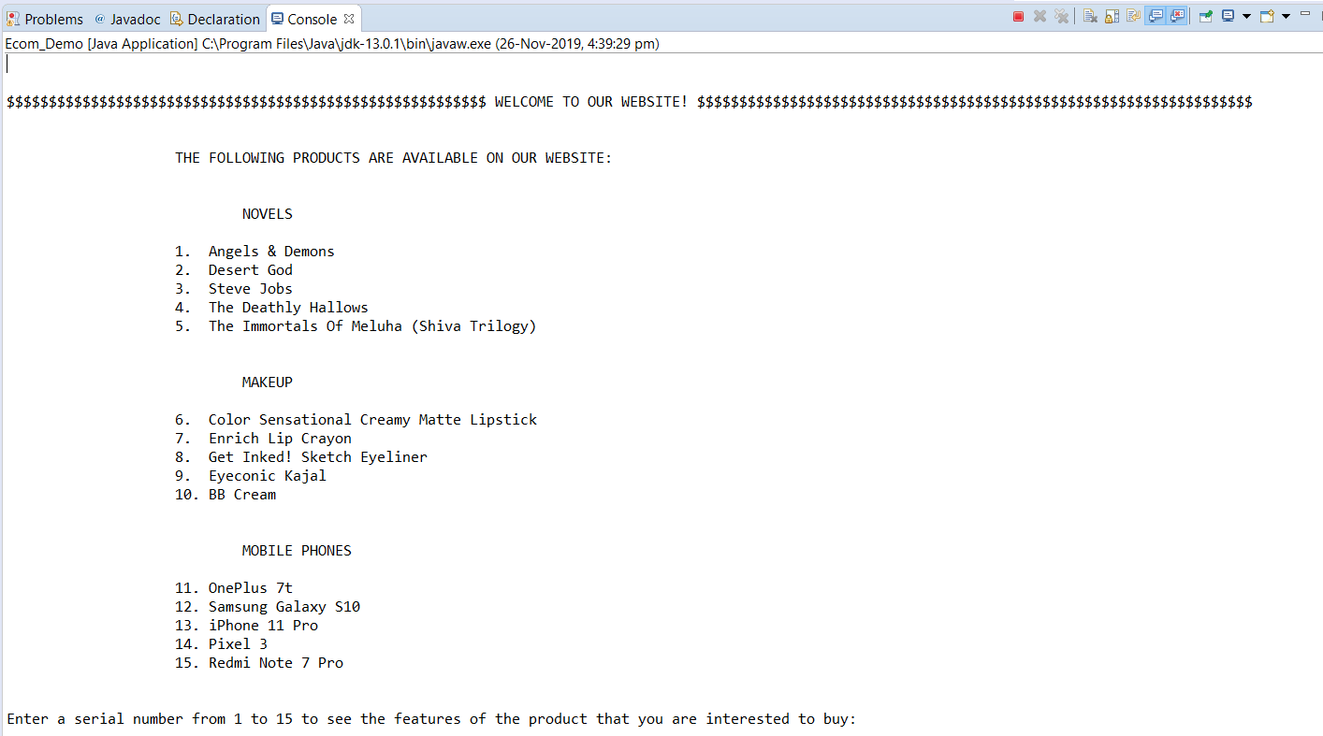

1. On selecting the item that you want to purchase it displays the information about that particular item. On proceeding, it also asks the user the quantity of the item and if the user wants to purchase any other items. It then displays a menu of various options.

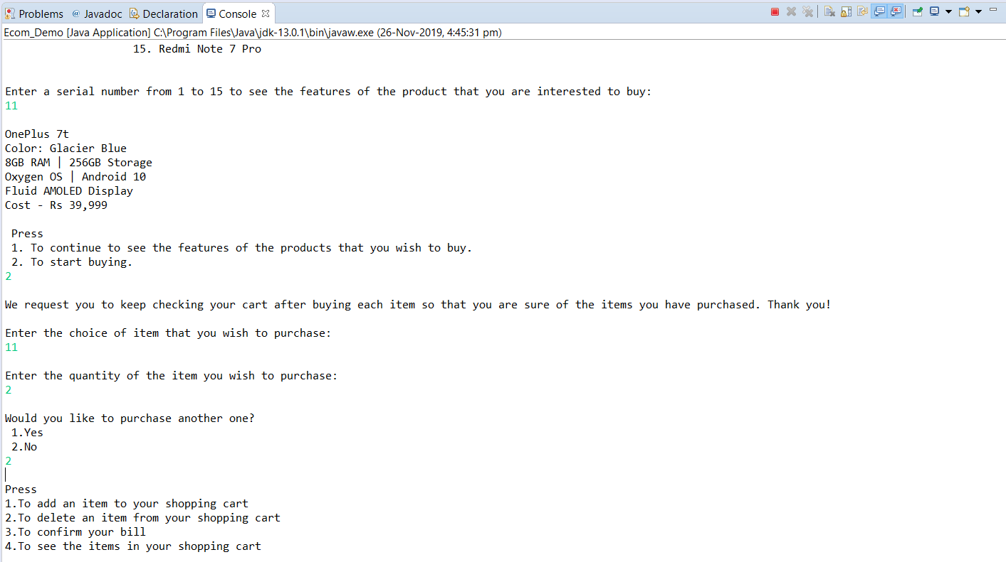

1. On selecting 1, it asks you the details of your purchase to make sure that you are choosing the right product. Later, on confirming the bill, it asks if the user is a member of the website. On selecting yes, it asks for the membership number and seeks permission if the user wants the amount to be debited from his account directly.

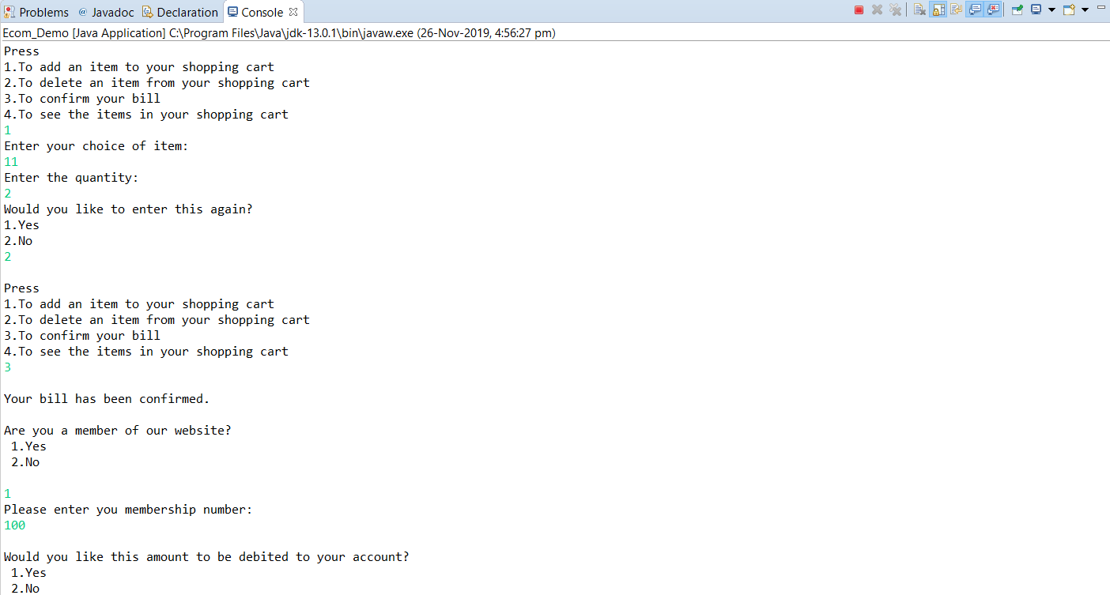

1. On selecting **No**, it asks the user the mode of payment. On selecting **Cash**, it generates the bill with the name of the item and the price along with the total amount. It asks the user to input the amount paid and generates the change to be paid back to the user. It then asks for the personal information of the user.

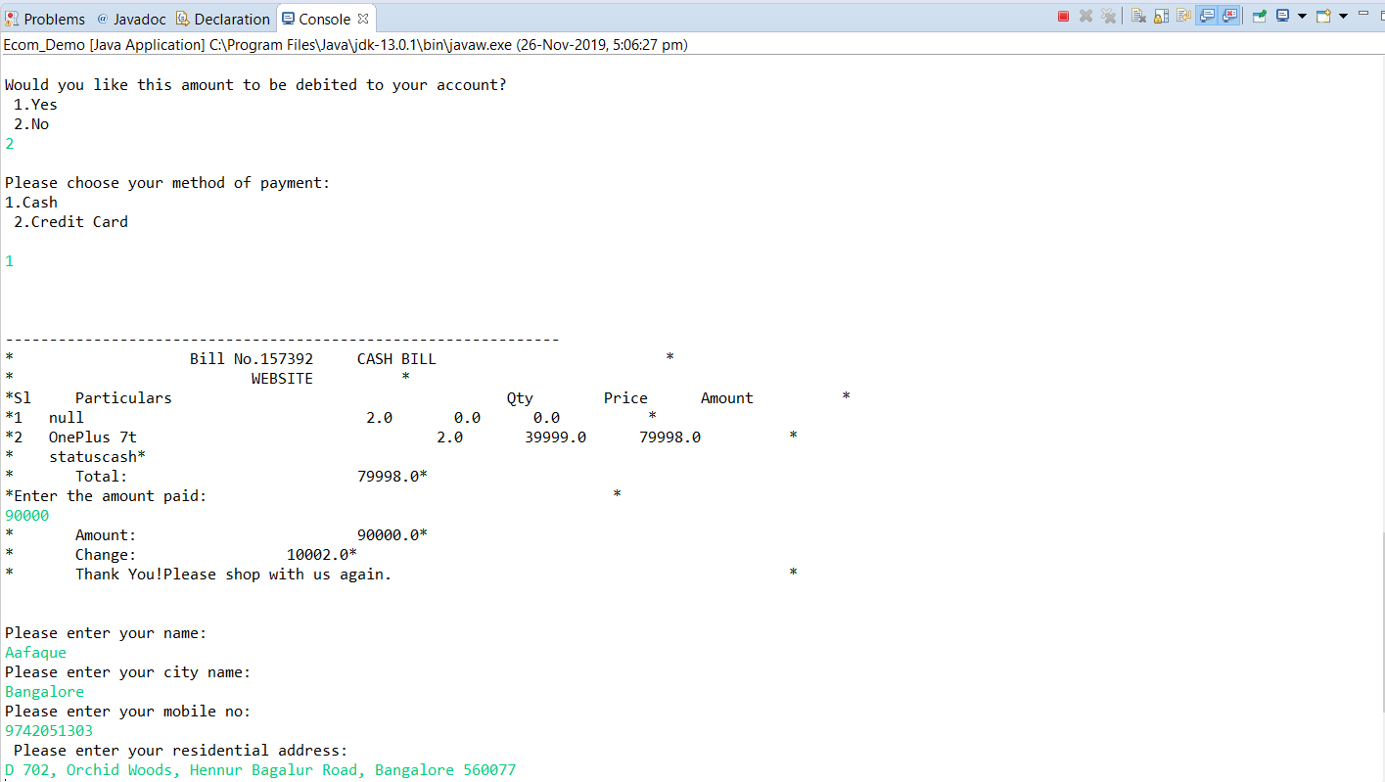

1. In the end, it displays a message with the name of the user, stating the estimated delivery time. It then starts the cycle all over again by asking the user to input the choice of item the user wants to purchase.

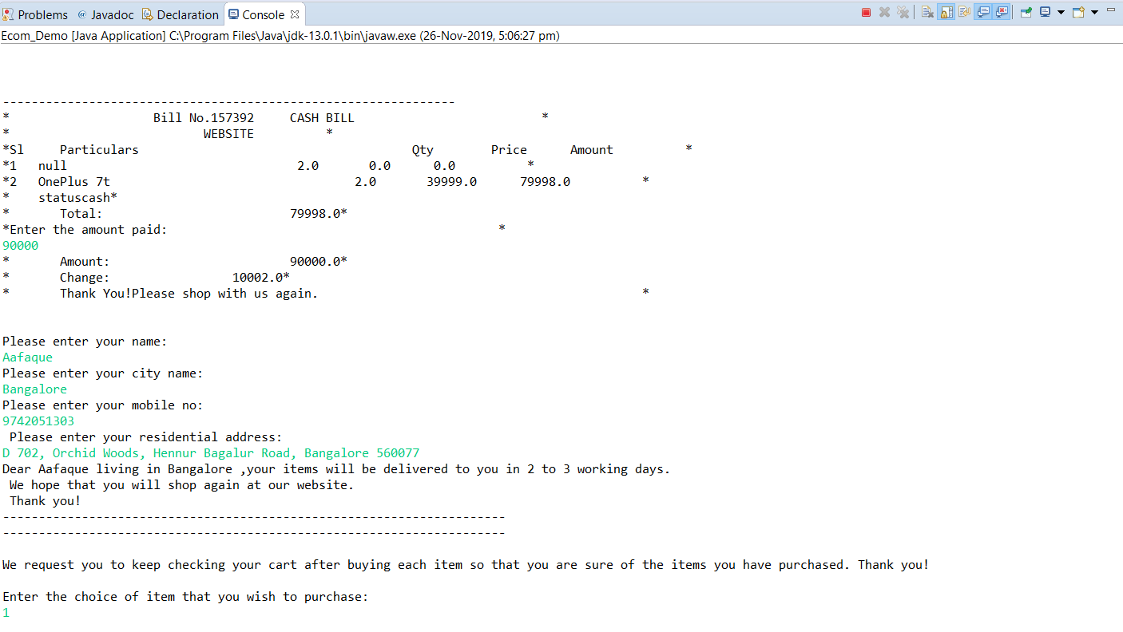

**CONCLUSION**

This mini-project implements the idea of an e-commerce site by using the Eclipse IDE and the Java programming language. Our program uses the basic interface of such a site by displaying a catalogue of various items that have been put up on the site to the user. The user can then choose which items he/she is interested and view information about them and then choose items that he or she wants to buy and in what quantity. These items are then displayed in a shopping cart, which also allows the user the option of adding and removing items. On confirming the bill, the user is asked to choose from a preferred method of payment and then asked to enter various details required for payment and shipping.

The online retail site developed in this mini-project thus mirrors the idea of a simple e-commerce site.

**FUTURE ENHANCEMENTS**

Future enhancements can be made to this online retail site with the help of MySQL. The Eclipse IDE can be linked to a MySQL database and previous order history and user details can be stored in this database, thus creating an account for the user to use whenever he or she wishes to use the site to place orders, thus eliminating the recurring process of entering personal details like name, phone number, address, etc. This will also make the site work more like how the more popular retail sites work.

**REFERENCES**

# [Java The Complete Reference, Seventh Edition (Osborne Complete Reference Series)](https://www.amazon.com/Java-Complete-Reference-Seventh-Osborne/dp/0072263857/ref=cm_cr_arp_d_product_top?ie=UTF8)

by [Herbert Schildt](https://www.amazon.com/s/ref=cm_cr_arp_d_pdt_bl_sr?ie=UTF8&field-keywords=Herbert+Schildt)

1. GeeksforGeeks ([www.geeksforgeeks.org](http://www.geeksforgeeks.org))
2. Youtube ([www.youtube.com](http://www.youtube.com))